**While migrating, you are asked to perform the following**

**tasks:**

1. Create a Redshift data warehouse.

2. Using the query editor:

a. Load some data

b. Query the data

search redshift 🡪open dashboard 🡪 click on create cluster.

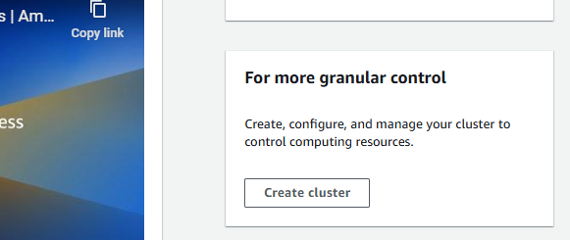

Chose size

We have choose single availability zone.

We will choose load sample data.

We have added username/password.

Create cluster.

Now we can see our cluster is creating.

Now go to the query editor on left side..

Connect to our cluster.

We can see data is already loaded with table 7.

Now run some commands.

